This past season, the Copper Cliff Minor Hockey Association was pleased to announce the return of two (2) academic bursaries.

The Ron DIDONE annual academic bursary – Member of the Sudbury Sports Hall of Fame, Ron dedicated decades as a coach and an executive board member within the Copper Cliff Minor Hockey Association. Ron always emphasized the importance of balancing minor hockey and academic performance.

The Gwen CREASEY Memorial annual academic bursary – Gwen spent many years and countless hours behind the scenes as a strong supporter in helping to build and strengthen minor hockey. Gwen had a love and passion for making hockey more accessible to all kids.

Requirements included applicants being in their final year of secondary school, registered with, and playing on a Copper Cliff Minor Hockey Association team for the entirety of the 2023/24 season. Furthermore, applicants were required to submit an acceptance letter from a post-secondary institution (University / College / Trades) for the 2024/25 school year, a letter of recommendation, and a short biography.

Awarded recipients were announced during the annual Ken Creasey House League Tournament earlier this month.

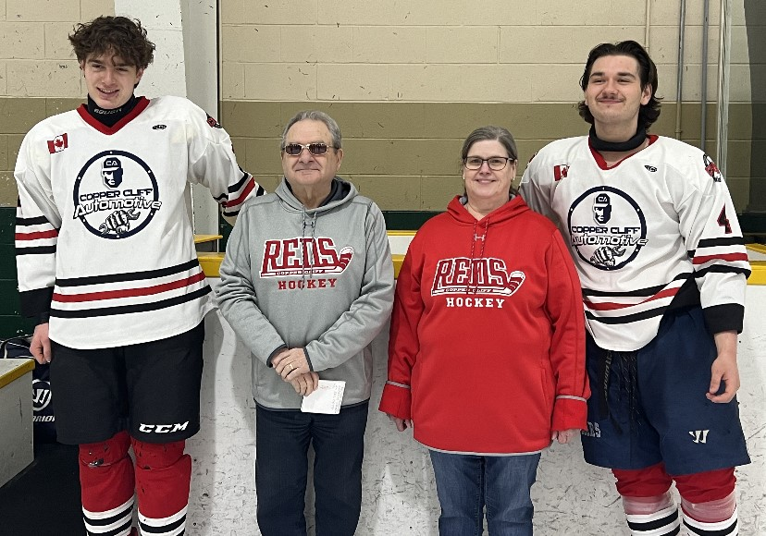

Russell Joiner [left] was awarded the Ron DIDONE academic bursary and received $750.00. Russell is a grade 12 student at Lo-Ellen Park Secondary School and will be attending Carleton University next fall to study Civil Engineering. Russell comes from a long line of family members who played within the CCMHA. Since moving to Sudbury at the age of 10, Russell continued the tradition by playing the entirety of his minor hockey career within our house league and rep programs. For the past two winters, Russell has volunteered with the Jackrabbits ski programs at Walden Cross Country.

Erik Piette [right] was awarded the Gwen CREASEY Memorial academic bursary and received $750.00. Erik is a grade 12 student at St Benedict Catholic Secondary School and will be attending Laurentian University next fall to study Accounting. Erik described learning important life values from hockey, like leadership, discipline, and teamwork. For the past number of years, Erik has volunteered his time at the Delki Dozzi Playground outdoor rink. His peers describe him as exceptionally dependable, hardworking, and dedicated to maintaining quality ice for his neighborhood.

The Copper Cliff Minor Hockey Association is dedicated to providing ALL the opportunities to play minor hockey. We promote the understanding of work ethic, good sportsmanship, discipline, teamwork, and the fair treatment of others. We further value the importance of education and wish to reward our graduating players as they pursue their post-secondary studies.

